Analysis of the UFO incident in San Francisco of Bellocq (Argentina)
(link)
I have contacted the newspaper "The Voice of the People" to request the original photograph of the UFO incident in San Francisco of Bellocq. Fortunately I have received the image in high resolution. It is impressive what i could see in it. The day August 26, in the morning, Andres Stessens, contributor to the municipal commissioner of San Francisco de Bellocq (Argentina) Gerardo Chedrese, took a series of photographs of the area with the purpose of assessing the state of rural roads and the flooded areas by the water after the passage of a storm.

The newspaper The Voice of the people issued a guidance note on the fact the next morning. I contacted with the person in charge of the Journal, I have received the original photograph. According to the news issued, Andres Stessens took the photograph in an elevated structure of the town, while he was accompanied by Gerardo Chedrese and two neighbors.

At the time of the capture, none of the witnesses saw the anomalous object, and with the passing of the hours, looking at the images they saw something unusual in one of them. According to the witness, immediately saw two objects in the image, one sharper than another, and with an oval shape or dish.

This is part of the communication of the eyewitness with the daily "The Voice of the People", is clearly noted in their expressions of doubt generated after witnessing an event of this type. "There is a strong and rare. Looking at the photo in the evening to discuss the impact of the water and as it was the people, we started to do a rapprochement with the zoom and we saw. Do one or two? Clarito is one and then to the distance there is another very similar, but much farther away, the more removed. I never had something like that, in a personal way never".

Analysis
The original photograph sent to exploracionovni.com has a resolution of 4000px by 3000px, and you can clearly see it as a way similar to a dish color silver or lead. You can see that the object is illuminated by the sun in the right direction, and then to analyze the image in a program of photography the diagnostic software, is that the image would not have been edited, and that would have been taken by a camera: Canon PowerShot SX130 IS with date and time of creation: August 26, 2014 10:18:44 AM. This coincides with the data provided to the newspaper The Voice of the people. Due to the fact that the original image is too large to be published on this site and also you don't appreciate the abnormalities present, the image has been reduced in size.

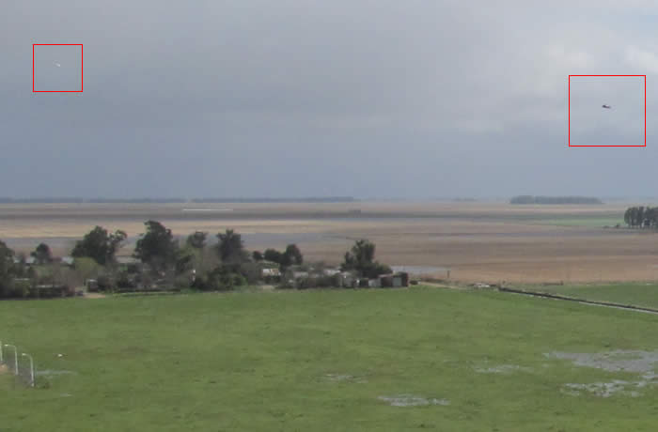
Imagen 1

After making an extension or zoom to the anomaly of the right (Figure 1) can be seen as follows (Figure 2). The object has an inclination and this may indicate that the object was moving. Also the direction in which the sun illuminates the object is the same as it illuminates everything else (trees, houses, etc.).
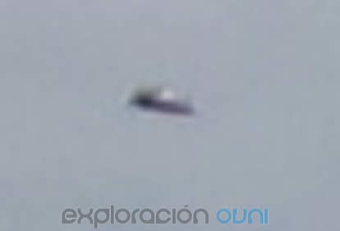
Imagen 2
After making an expansion or zoom to the anomaly of the left (the less visible) and applying filters (brightness and contrast) can be seen a kind of sphere floating on the area, and that (I'm speculating) could be related to the object on the right. It seems that the sun was lighting up the right side of this other flying object, but the structure is different from the other object in the image.

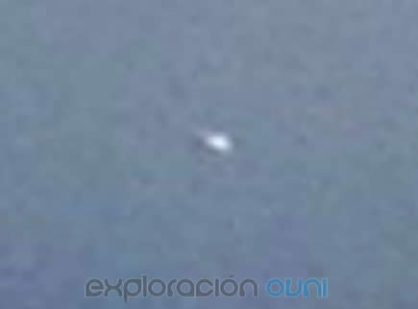
Imagen 3

Conclusion

- I have ruled out that the cause is due to mistakes by photography, or spots on the lens or birds.

- I can't relate the objects with artifacts or ships known (aircraft, helicopters, drones). In addition, the principal object, in relation to the distance, seems to have a significantly large size.

- The image analysis in several photo software revealed that the image has not been edited. Furthermore, the creation date, of EXIF data, match those stated by the witness.

- I have tried to contact the witness and person who took the photograph Andres Stessens, but after 4 days I don't have received no reply. On the basis of what was said above, in the analysis of the image, I can categorize this case as UFO, because I couldn't find a natural cause or logic to explain this fact.

Analysis by Fernando Távara
http://www.exploracionovni.com
http://mufonperu.org

